Terraform task 4
- Install Terraform on your PC
Go to the website https://developer.hashicorp.com/terraform/install
#Steps To Install Terraform on Windows 10 or 8 or 7
1) Download Terraform
https://www.terraform.io/downloads.html
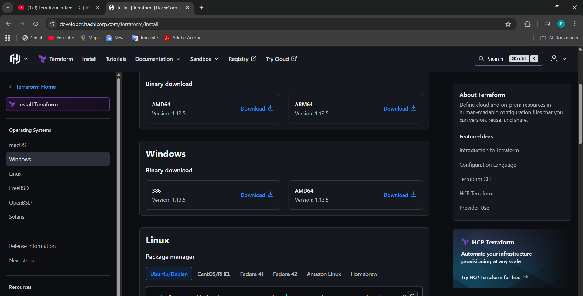
2) Unzip the terraform package
Once download the package and extract the file to the C disk location
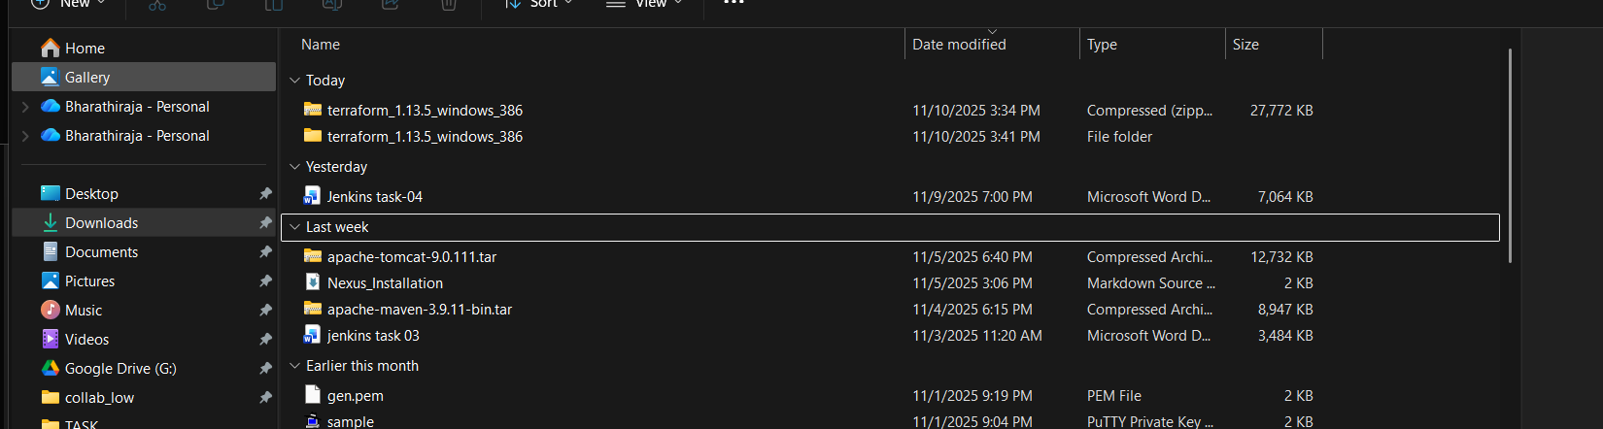
Then, after downloading part, open the git bash open the check the Terraform location 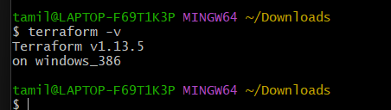
Go to the search part in Windows Search system variables, a window will open, click on that environmental variable
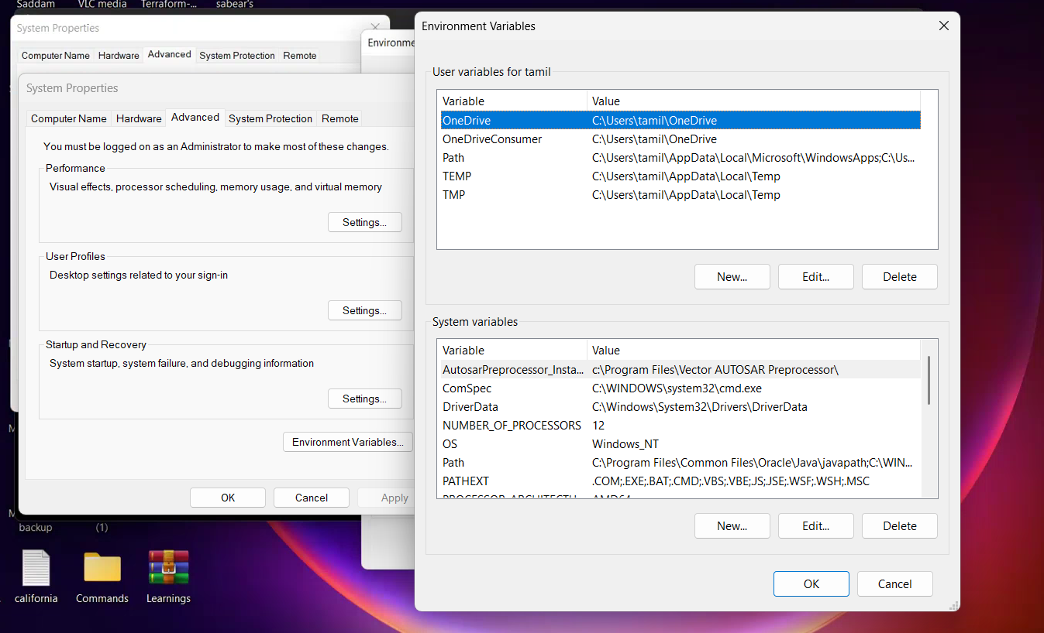

Open a folder like Terraform bharathi name I mentioned
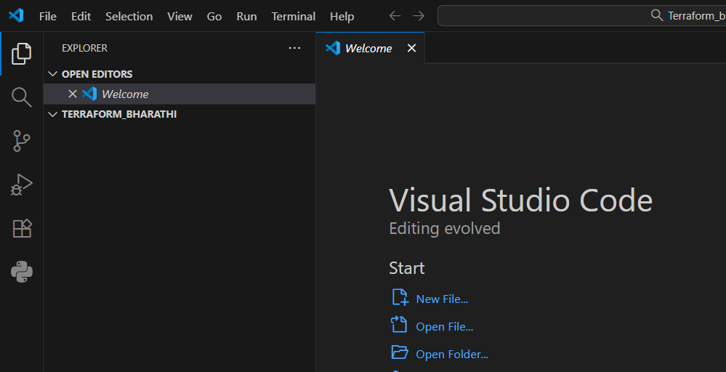
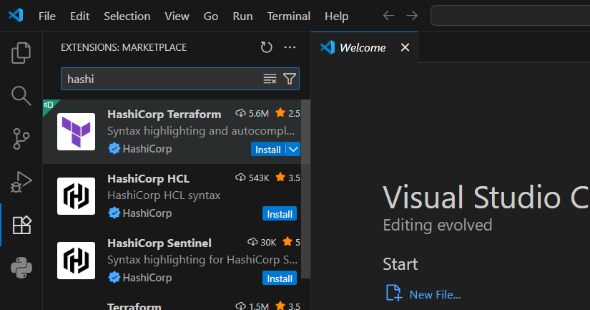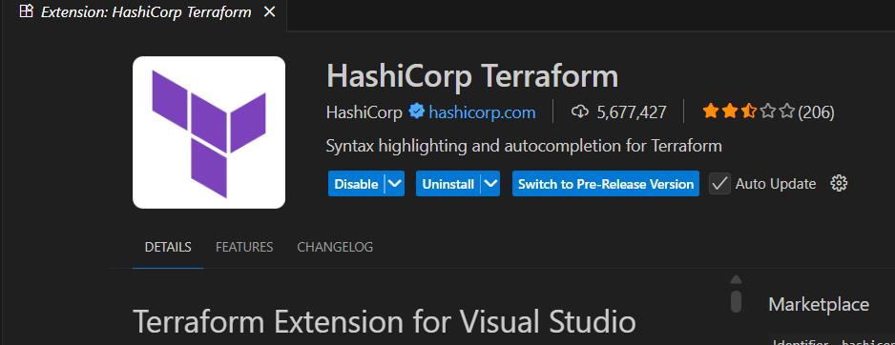
Then, after create a Visual Studio, execute the code
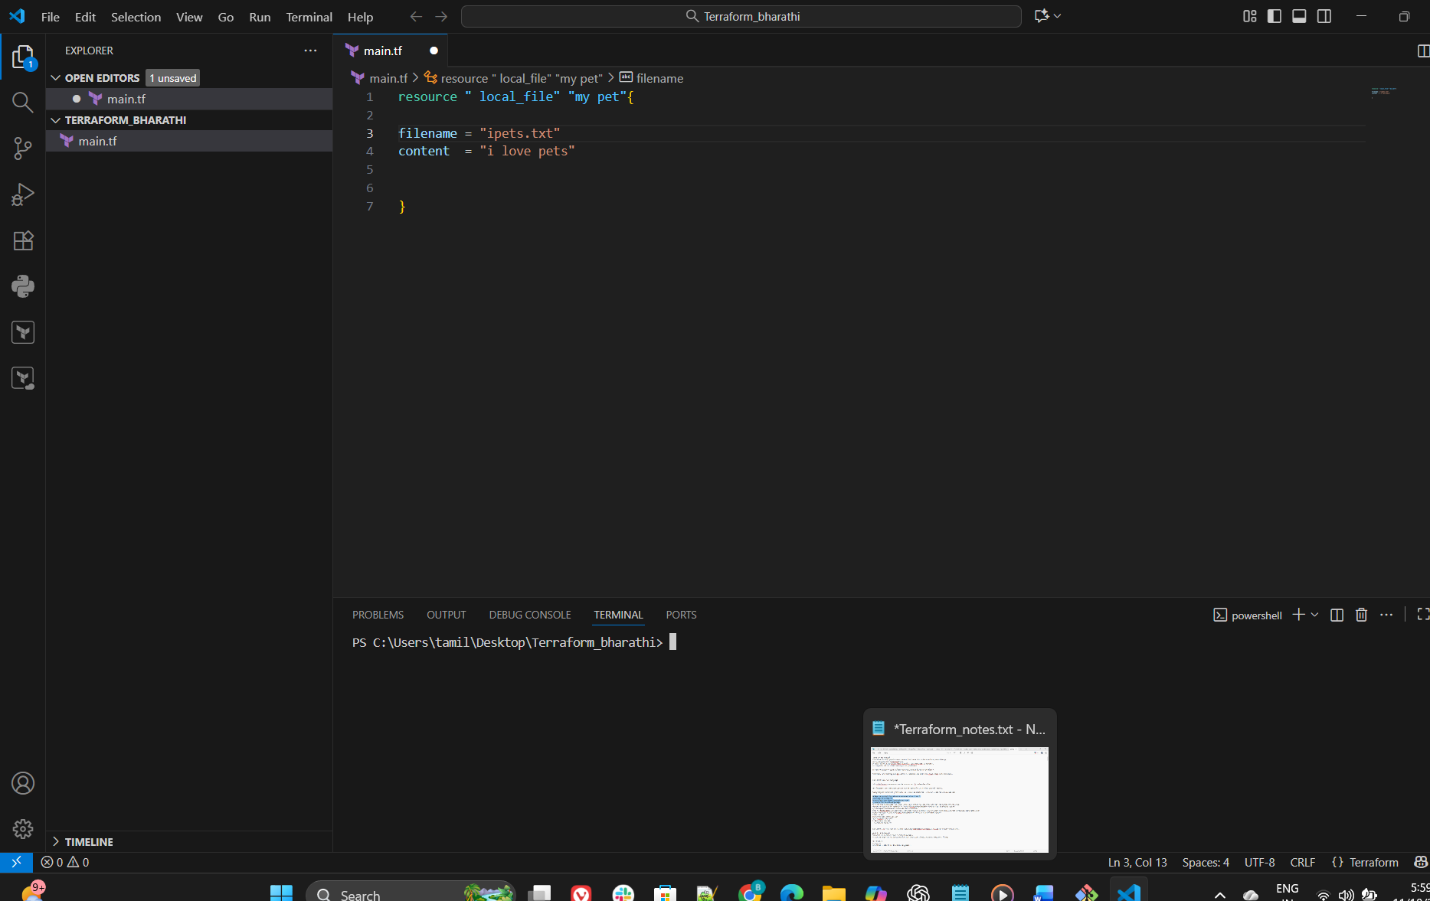
Give ls and
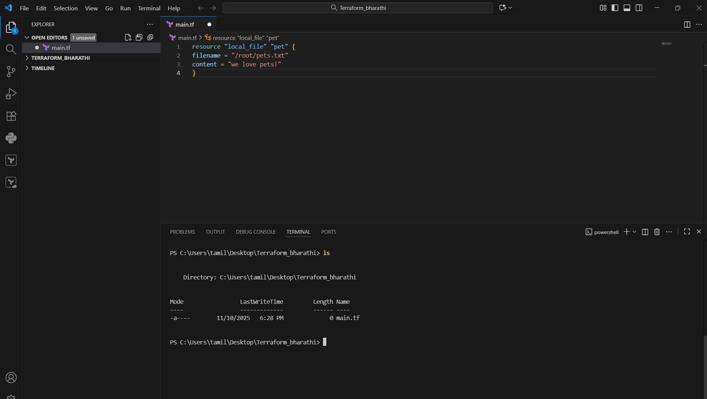

Terraform init for init
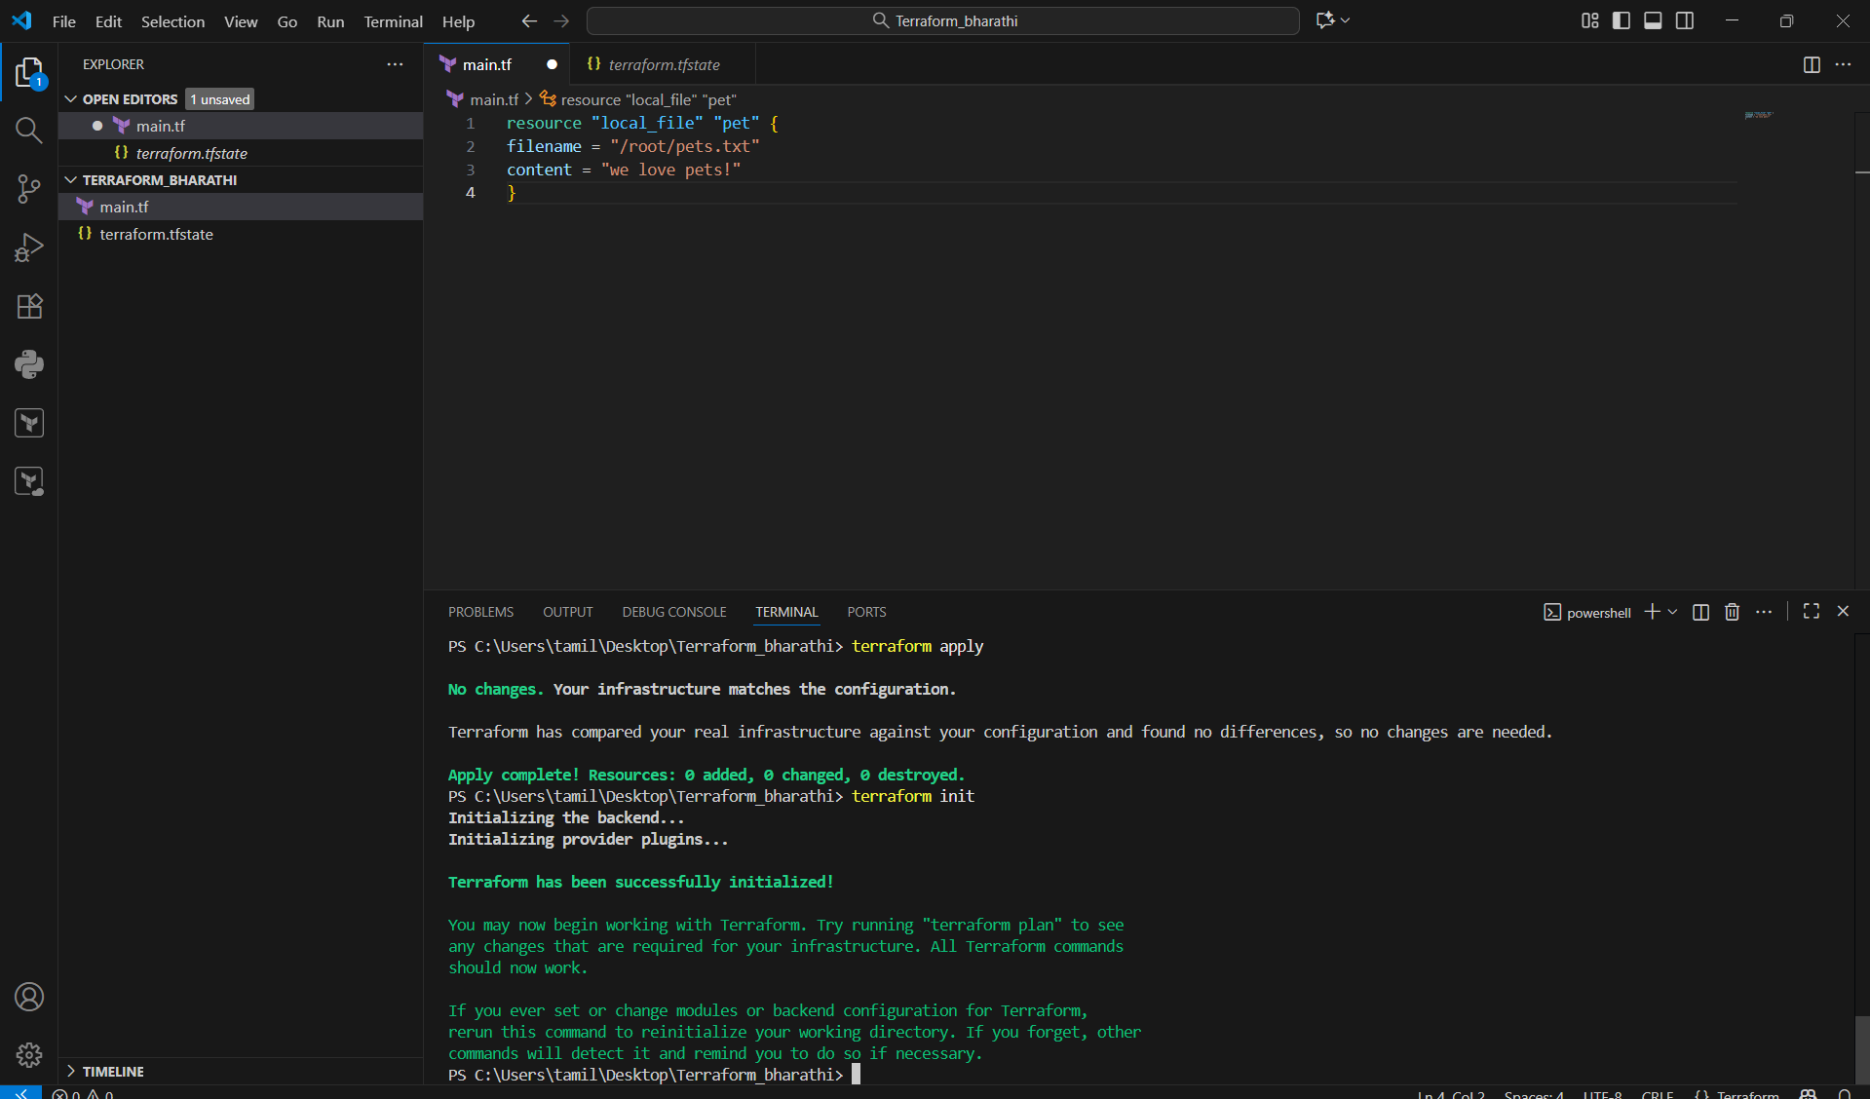
First save the execute

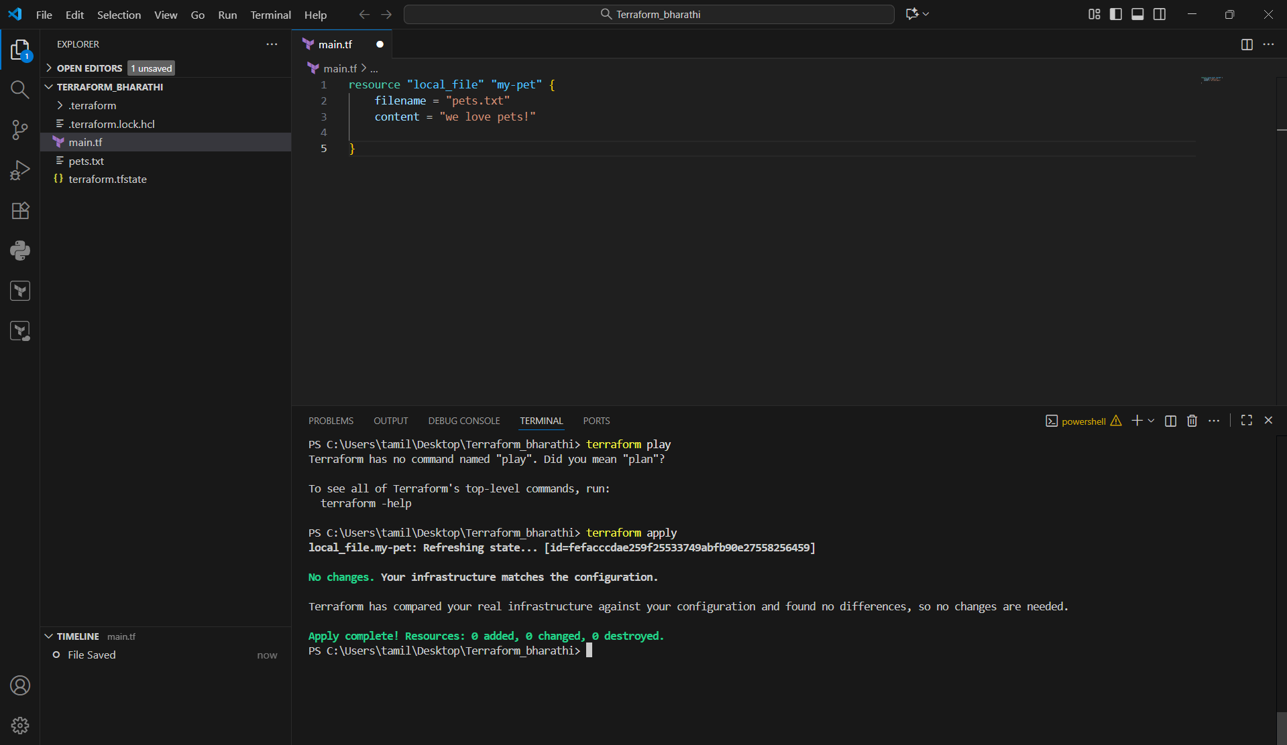
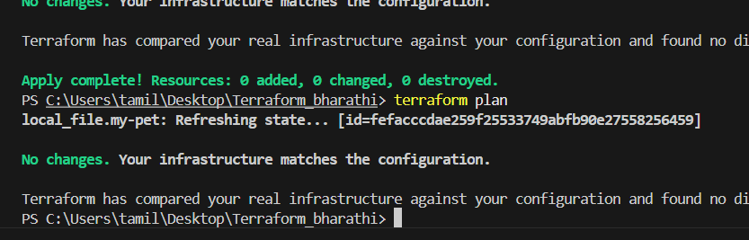

- Note down below points, Terraform Init , Terraform Plan , Terraform Apply , Terraform Provider.

terraform init --> to initliaze the repository and download the dependencies
terraform plan --> dry run to check how it will be create the respource (It will not actually create them)
terraform apply --> to execute and create the infra based on the configuration
terraform destroy --> to remove/delete the existing infra.
terraform show --> to show/get the details of the resources created

Integrate a sample Terraform template in Jenkins.
we have to follow these steps with skiping
- Create jenkins-keypair.pem
- Create jenkins-sg security group (allow SSH, 8080)
- Launch EC2 instance for Jenkins
- SSH into EC2 and yum update -y
- Install Java, Git, AWS CLI, Terraform
- Install Jenkins and plugins (Pipeline, Git, Credentials Binding)
- Create IAM user jenkins-terraform with programmatic access; note keys
- Add Jenkins credentials (username/password) with AccessKeyID & Secret
- Push Terraform files to Git repo
- Create Jenkins pipeline job or put Jenkinsfile in repo
- Run job → approve apply → verify resources in AWS
- Destroy resources when done

Step 1)
Go the Jenkins first, the plugin the Terraform
In the Jenkins instance, we have to install Terraform. I mention that below.
sudo yum install -y yum-utils shadow-utils
sudo yum-config-manager --add-repo https://rpm.releases.hashicorp.com/AmazonLinux/hashicorp.repo
sudo yum install terraform

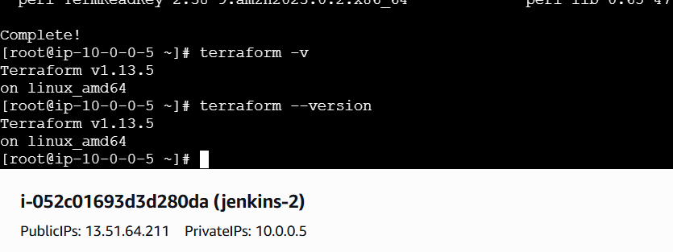
Git clone link to download the code files
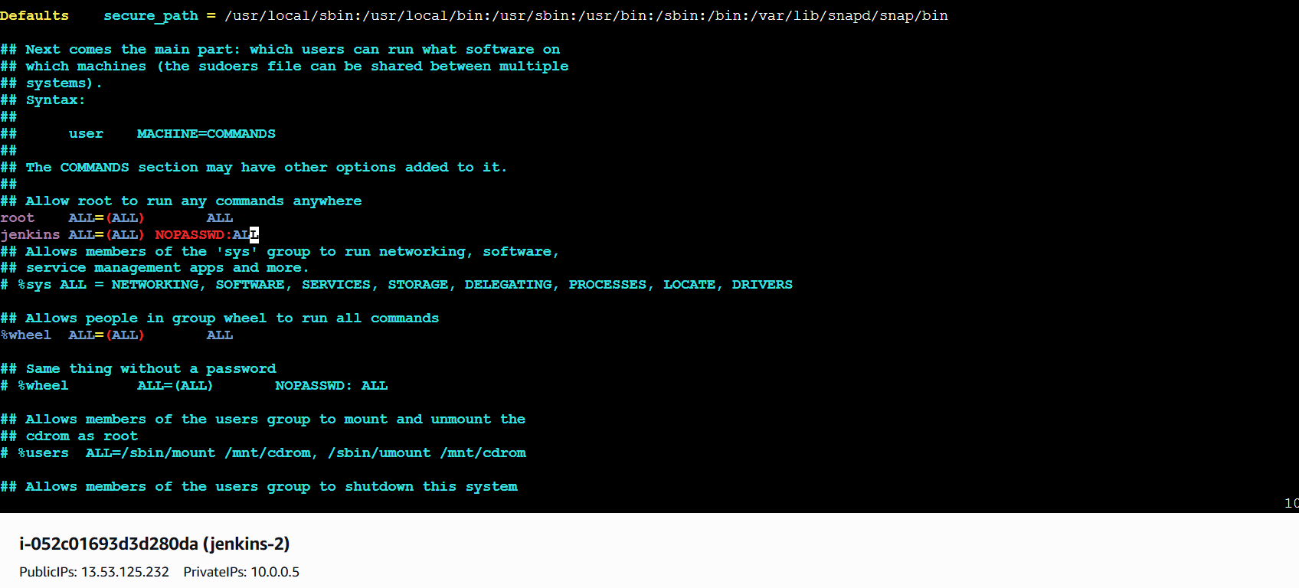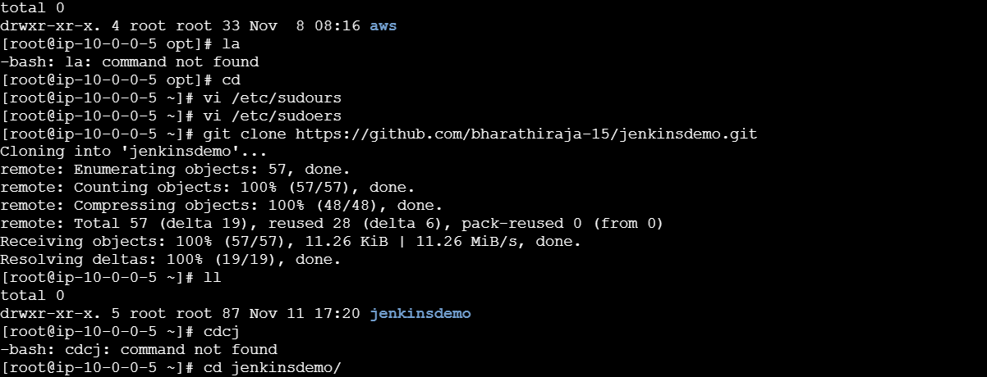
We have to changes Jenkins ALL=(ALL) NOPASSWD:ALL

THEN GO TO JENIKNS CREATAA PROJECT
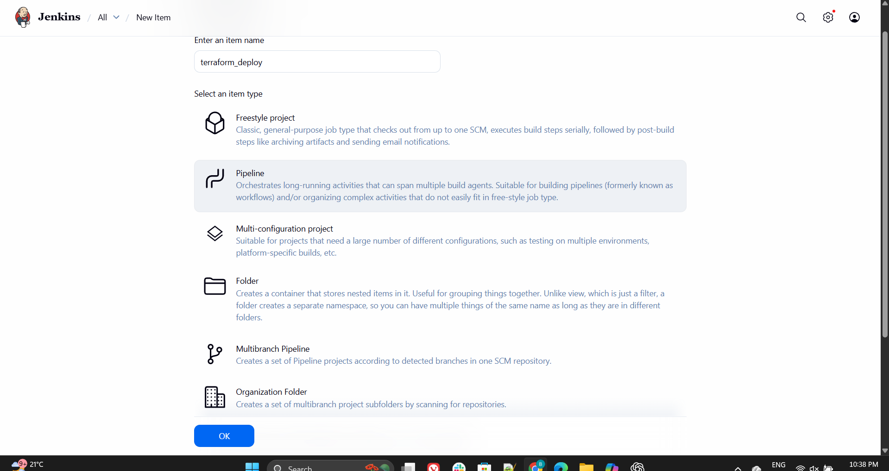
INSTALL TERRAFORM PULGIN
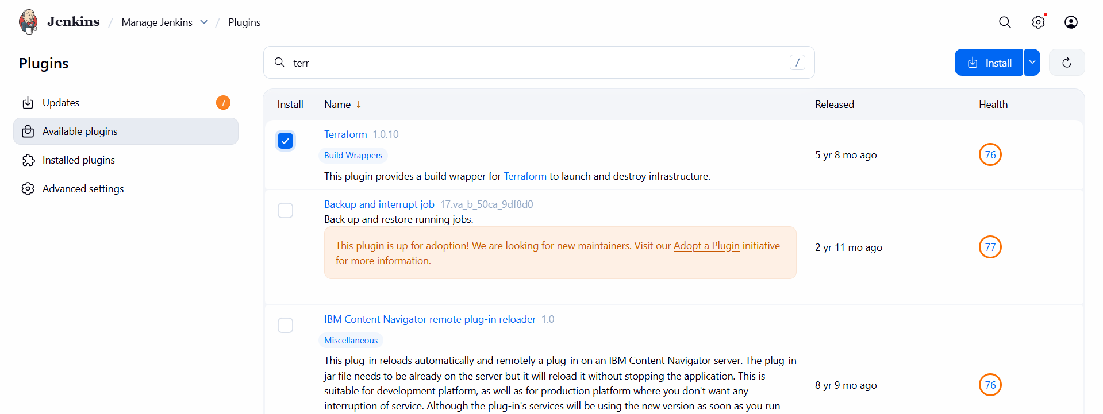
GIVE WHICH BRANCH IN THE GIT LINK
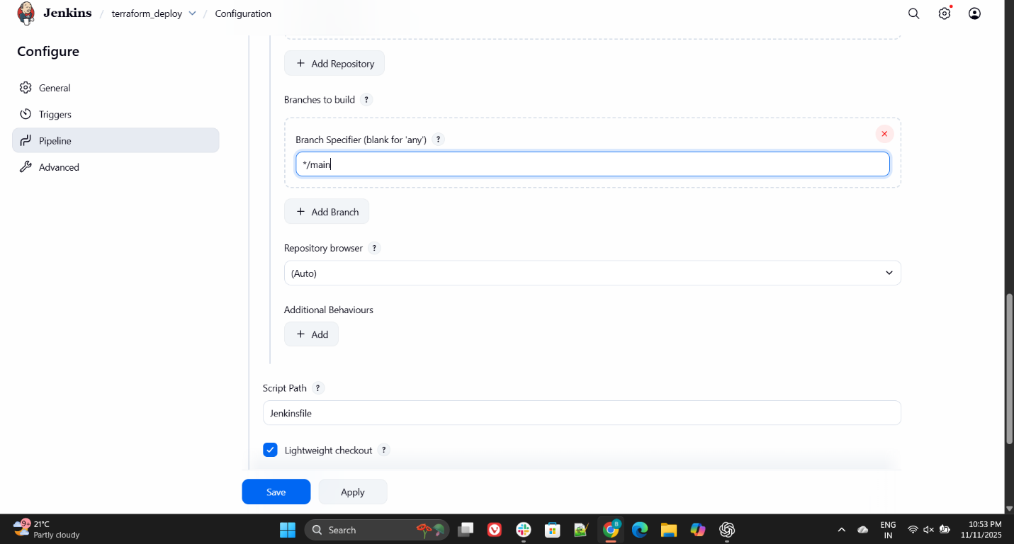
PASTE THE LINK GIT 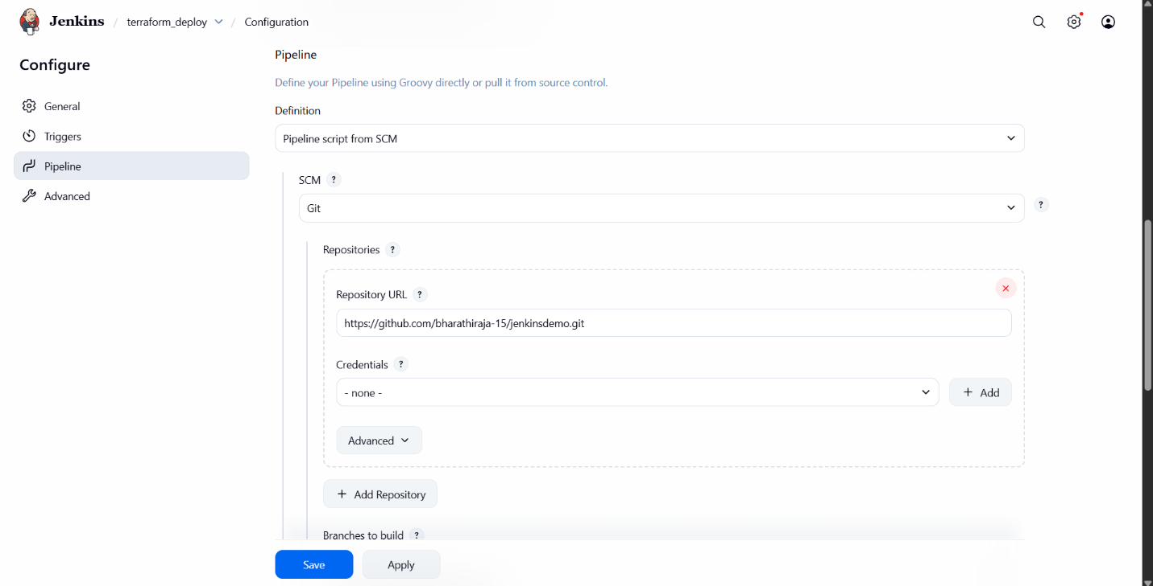
CREAT IAM ROLE FOR REGIONS AND FULL ACCESS
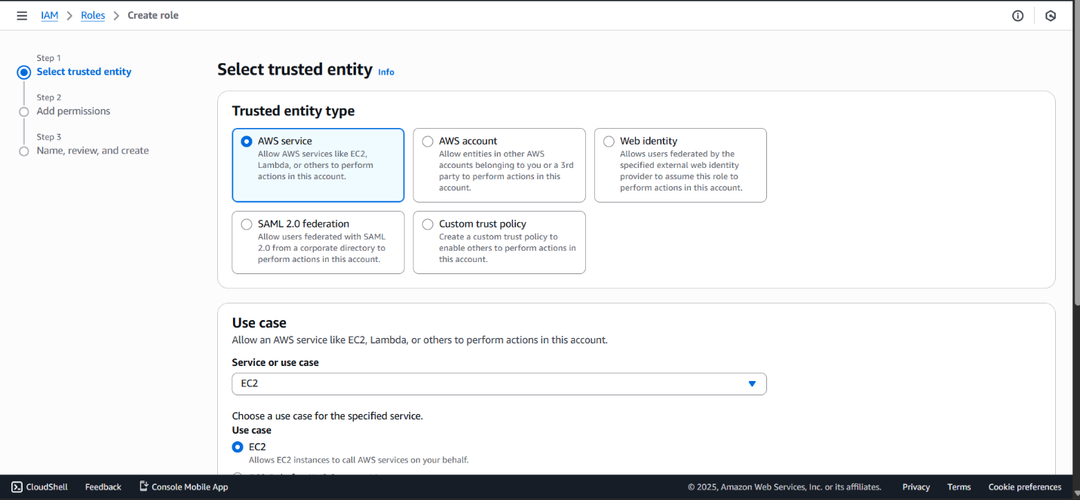
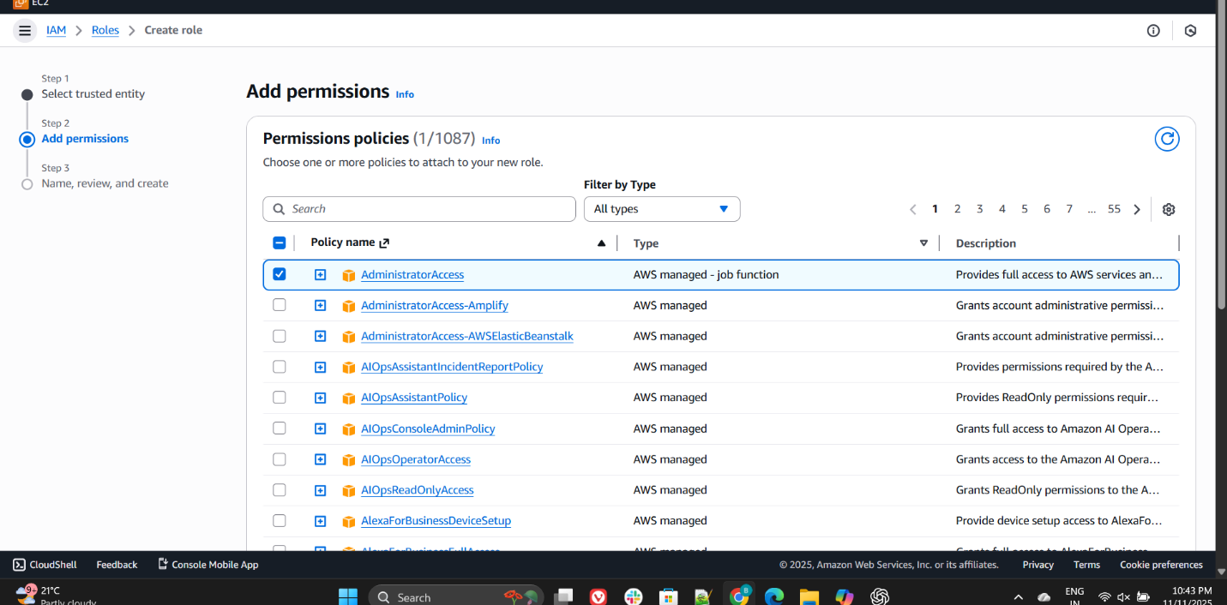
Give the name of the role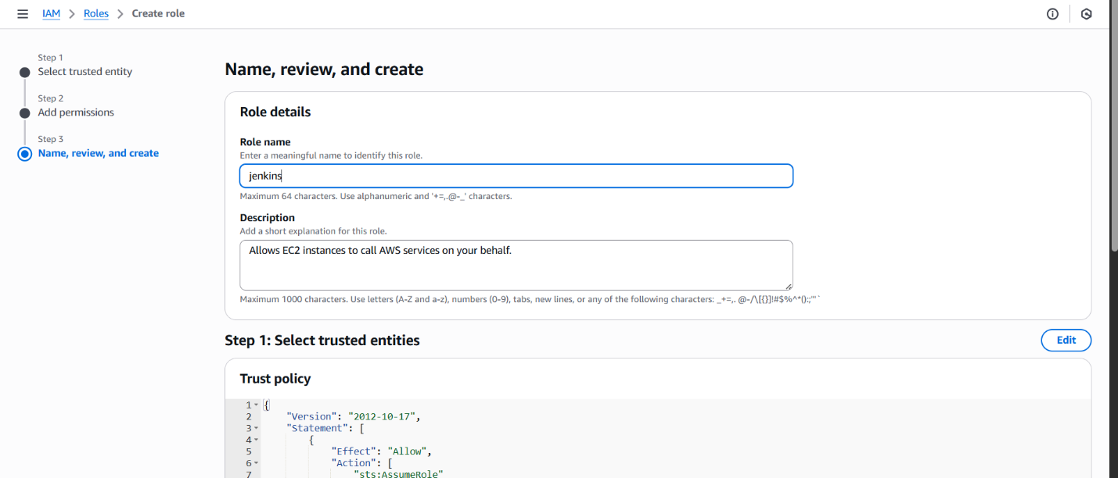
Where are you going to add the role we should choose
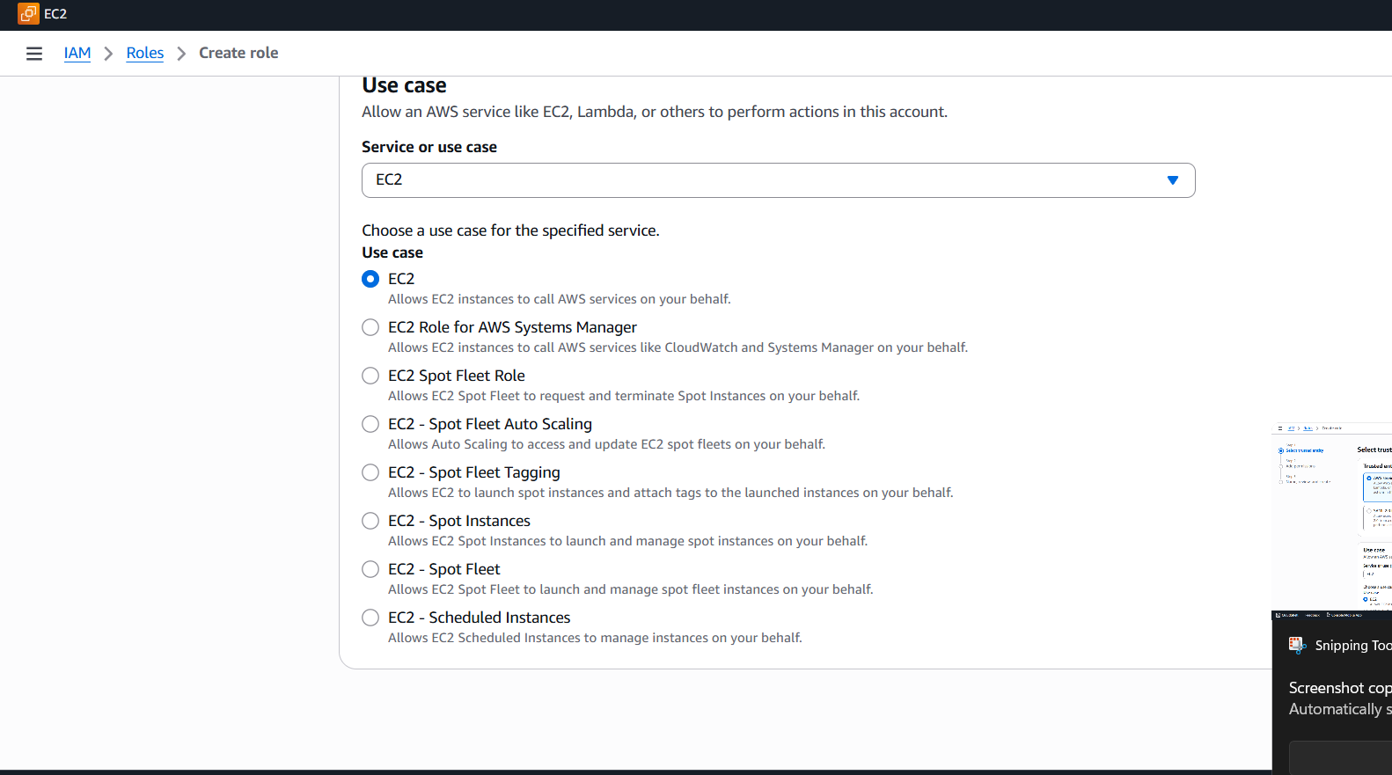
ADD THE ROLE TO JENKINS ATTACH THE ROLE IT JENKINS
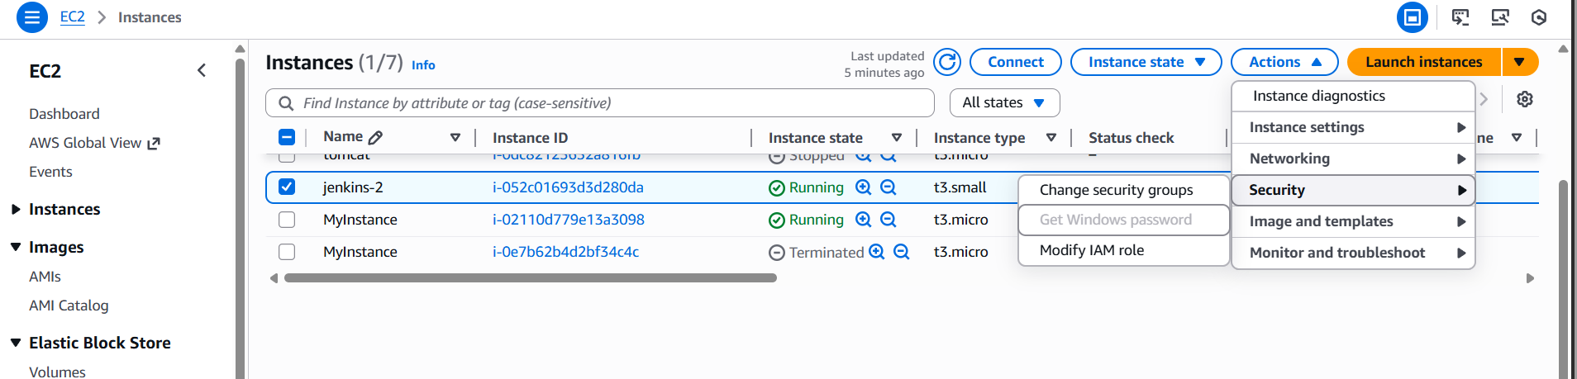
Run Jenkins, and it will deploy automatically CREATE THE INSTANCE

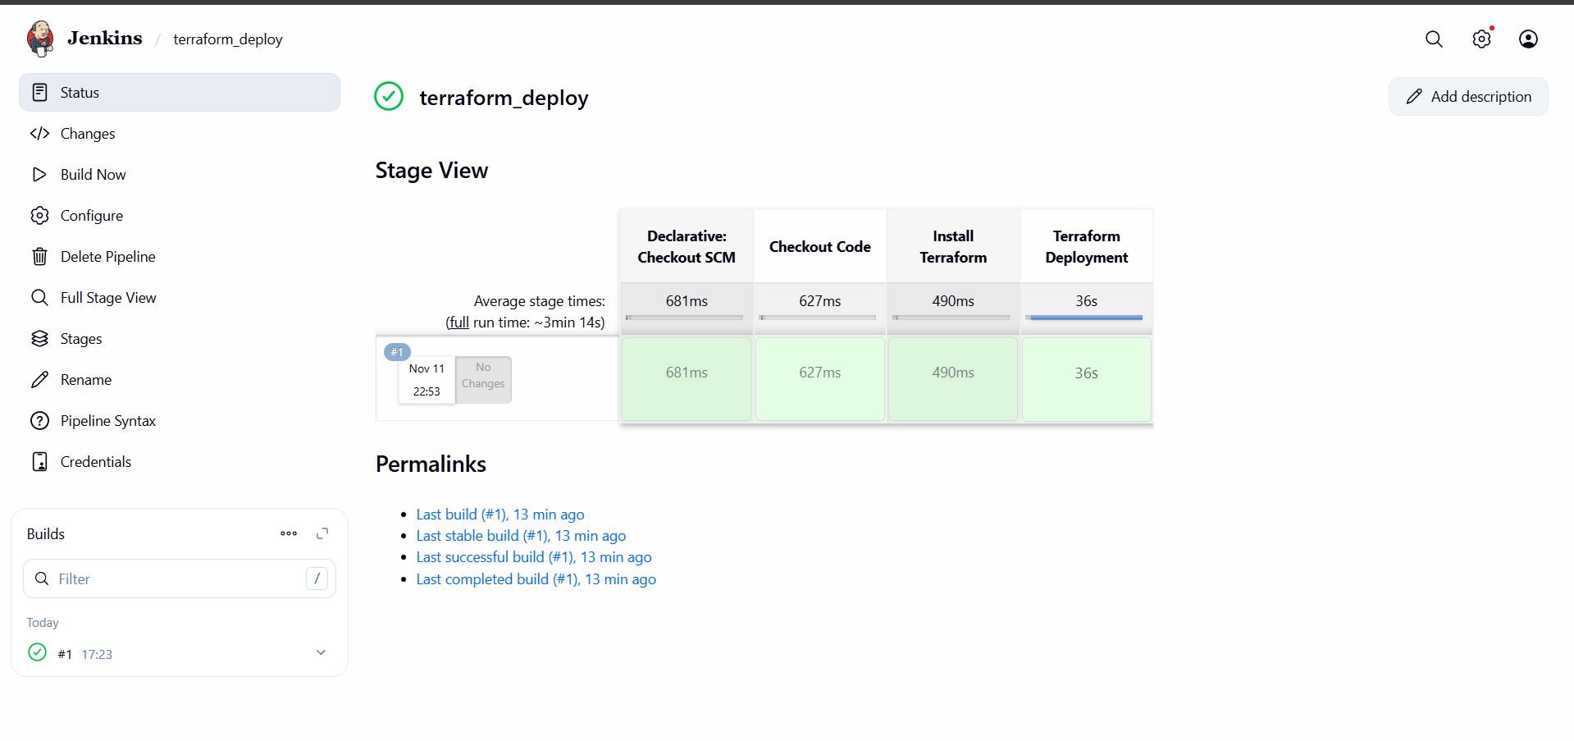
Ec2 instance created
